Project Design Phase-II
Technology Stack (Architecture & Stack)

Date | 30 September 2026
Team ID | SWTID-2026-7764
Project Name | Import Data using Transform Maps (Spreadsheet)
Maximum Marks | 4 Marks

Technology Stack and ServiceNow Architecture
This project uses the ServiceNow user interface and native tables, Import Sets, Transform Maps, Reports, and Dashboards, with an XLSX workbook as the source.
Project architecture: Sample Spreadsheet.xlsx to Employee Import staging, Sample Spreadsheet Import, Employee Test, and the Employee Analytics Dashboard.
Project reference: supplied implementation walkthrough.
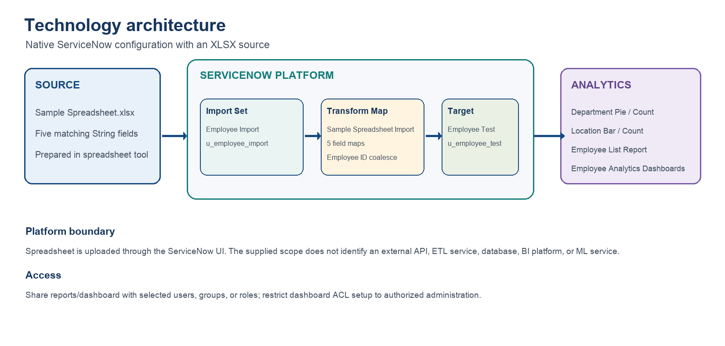

Table-1 : Components & Technologies:
S.No | Component | Description | Technology
- 1 | Source file | Sample Spreadsheet.xlsx; source headers: Employee ID, Name, Email, Department, Location. | Microsoft Excel / XLSX
- 2 | Platform interface | Application Navigator, Load Data, tables, transform maps, lists, reports, and dashboards. | ServiceNow UI
- 3 | Target data model | Employee Test with internal name u_employee_test; all five fields are Strings. | ServiceNow custom table
- 4 | Staging | Employee Import label; staging table u_employee_import is auto-populated when created. | ServiceNow Import Sets
- 5 | Transformation | Sample Spreadsheet Import; Employee Import source and Employee Test target. | ServiceNow Transform Maps
- 6 | Field mapping | Auto Map handles the four same-named columns; use Mapping Assist for Name → Employee Name. The five maps are: Employee ID → Employee ID; Name → Employee Name; Email → Email; Department → Department; Location → Location. | Transform Map field maps
- 7 | Duplicate handling | Employee ID is configured with Coalesce so existing employee IDs are matched. | Transform Map coalesce
- 8 | Analytics | Department pie/count; location bar/count; employee list; consolidated dashboard. | ServiceNow Reports and Dashboards
- 9 | Access and sharing | Share reports/dashboard with selected users, groups, or roles; dashboard creation ACL setup is administrator-only. | ServiceNow sharing and ACL configuration
- 10 | External components | No external APIs, ETL service, database, BI platform, or ML service is identified in the supplied scope. | Not specified / out of scope

Table-2: Application Characteristics:
S.No | Characteristics | Description | Technology
- 1 | Platform boundary | Use the supplied ServiceNow instance and built-in import/reporting capabilities. | ServiceNow
- 2 | Data consistency | Use source headers Employee ID, Name, Email, Department, Location; map Name → Employee Name and the other four columns by name. Preserve Employee ID. | XLSX and field maps
- 3 | Repeat imports | Coalesce on Employee ID and review transform history after every run. | Transform Map
- 4 | Controlled sharing | Limit report/dashboard visibility to intended users, groups, or roles; ACL changes require authorized admin review. | ServiceNow access controls
- 5 | Performance evidence | Record workbook size, run time, staged rows, and transform outcomes if formal performance measurements are required. | Instance measurements; thresholds TBD

